Azure BSCNE Capstone
Project Approval Form

Introduction
The purpose of this document is to help you clearly define your capstone project scope and to ensure the project will support the task requirements. Your final Azure hybrid network project will be evaluated based on its ability to satisfy 8 test-case scenarios.

A clearly defined scope is essential for your capstone instructor to accurately assess the validity of your proposed network project and the expected timeline for completion. Work with your instructor before submitting this form if you are unclear on the organizational need or what an appropriately sized network will include. If applicable, scale your network project to no more than that of a 10-user network. A network that is too small will not have all of the connections or devices that are required to validate each of the eight required test cases. A network that is too large will take unnecessary time and effort for you to build, test, and deploy. Students must create a network that uses both on-prem and a simulated cloud-based environment in the Azure platform.

Complete this project approval form by identifying the organizational overview, network scope, and network diagram for your proposed network project. Additionally, review the seven predefined test-case scenarios to be validated against your network project. Your network project must be built in a virtual lab environment using GNS3 and Azure for the cloud provider. It is recommended to explore the virtual lab environment and the included GNS3 tools during the planning process to ensure alignment between the proposed network project and the available virtual networking tools.

Please note: If you are using proprietary content from a third party, please ask your course instructor for a release form.

Email this completed form directly to your capstone instructor for approval. Once approved, you will receive a signed document in PDF format that you will upload as part of Task 1.

Organizational Overview
Provide one to two paragraphs that describe the organizational need or opportunity that your network will support. If needed, a fictional organization may be used to provide context to the need or opportunity.

The company, Meridian Geospatial Solutions, is a specialized environmental consultancy firm that offers high-resolution mapping solutions and real-time data analysis support to urban development and conservation initiatives. Traditionally, the company has operated out of its two-story headquarters, where all client data is centrally managed on its internal server farm. However, the recent upsurge in international contracts has created the need for a more scalable solution. Currently, the organization's infrastructure is unable to cope with the compute-intensive processing required for modern LiDAR rendering.

To mitigate these problems, Meridian is shifting its infrastructure to a hybrid cloud solution, expanding its physical footprint to include Azure. This would enable the company to use the server subnets available in the cloud to process data while controlling its identity and security models at the home office. This would enable the company to create a Site-to-Site VPN and centralized DHCP/DNS solution, which would enable its 'First Floor' and 'Second Floor' teams to be able to collaborate with the assets available in the Azure solution. This would not only provide the scalability required for the project but also improve the solution's security by leveraging the centralized pfSense firewall.

Network Scope
Provide one to two paragraphs that describe the main purpose and function of the network that you will build. Additionally, identify a tentative timeline of the anticipated future project start date, end date, and any major milestones to be completed during development.

The main purpose of the Meridian Geospatial Solutions network is to build a hybrid network that provides high availability with a physical network infrastructure on two floors in the headquarters building and a cloud-based infrastructure on Microsoft Azure. The network is also an ecosystem in which Windows Server-based services provide identity and configuration services for both workstations on the network and cloud-based application servers. Using pfSense as a central security gateway provides encrypted communication and access for Site-to-Site (S2S).

The purpose of this network solution is to help the firm transition from a traditional local network environment to a more scalable "cloud-adjacent" solution. The solution uses 802.1q VLAN trunking for departmental network segmentation across floors, as well as Network Security Groups (NSGs) and User-Defined Routes (UDRs) in Azure to prevent lateral movement. The solution enables the firm to leverage cloud scalability for geospatial data processing while maintaining a central on-premises management plane, enabling the scalability required for global contract work while preserving the existing security posture.

Project Timeline and Milestones
The execution plan for the Meridian Hybrid Network is expected to launch on August 1, 2026, and go live by October 30, 2026. The project will be conducted in phases to ensure no disruption to the consultancy business.
- Phase 1: Core Infrastructure Setup – August 1 to August 21: pfSense firewall configuration, Main Core Switch configuration, and VLAN configuration for VLAN-10, VLAN-20, and VLAN-30
- Phase 2: Integration of Identity & Services – August 22 to September 11: Configuration of Windows Server VM for ADDS, DHCP, and DNS, and Entra ID Connect configuration
- Phase 3: Azure Connectivity & Routing – September 12 to October 2: Configuration of Azure Virtual Network Gateway, S2S VPN Tunnel configuration, and configuration of UDR tables and NSG rules
- Phase 4: Remote Access & Testing – October 3 to October 23: Deployment of P2S VPN tunnel and rigorous 'fail-safe' testing of egress traffic routing and security policies.
- Phase 5: Final Documentation & Handover – October 24 to October 30: Completion of network topology diagrams and formal handover to the IT operations team.

Network Diagram
Provide a complete graphic diagram of all physical devices and connections for your proposed network.

You may use any graphic tool to create this diagram (Visio, PowerPoint, GNS3, etc.). Still, you must provide a clean and readable image pasted into this approval form (or attached as a PDF) when you submit the form to your instructor.

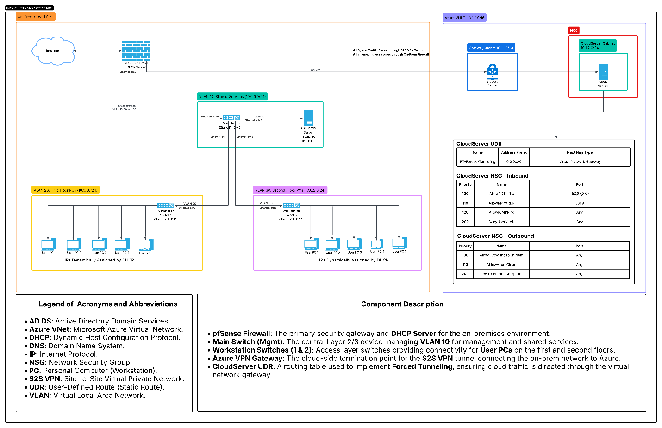

Test Case Scenarios

Predefined Test Cases
Review the eight predefined test-case scenarios to ensure alignment with your proposed network project. Your project will be required to satisfy all seven requirements adapted to your networking use case.

TEST CASE | REQUIREMENT
Test Case #1  Local Networks - Basic Network Segmentation at Layer 2 via VLANs and 802.1q | Your network traffic should be segmented per department or service function at Layer 2 to enhance security and reduce network congestion at the switching layer while allowing segmented traffic to traverse between switches (VLAN trunking). For each setup, describe your configuration choices and how you verified that the network segments are isolated and that any allowed communication works correctly.
Test Case #2  Local Networks - Accessing External Resources—Routing and Traffic Security | User devices on your network should have dynamic addresses that are assigned through DHCP unless they provide a service that requires a static address. You must also have at least one network resource that requires a static address.
Test Case #3  Local Networks – Device Discovery and Reachability | Your network solution must include multiple network segments with access controls that allow traffic from a device on one network to access the resources of a device on another network. Similarly, there must be devices on one network that cannot access resources on a different network.
Test Case #4  Cloud Networks - Network Segmentation | Your cloud network traffic (e.g., VPC, VNet, or similar) should be segmented using subnets, virtual networks, or equivalent constructs to enhance security and reduce congestion. You must ensure segmented traffic can traverse between subnets or virtual networks as needed (e.g., cloud routing tables or equivlent). Within your chosen cloud platform (Azure), your network traffic should be segmented using platform-specific components.
Test Case #5  Cloud Networks – Accessing External Resources-Routing and Traffic Security | Your cloud networks should typically use dynamically assigned IP addressing from the cloud platform unless they provide a service that requires a static IP address. You must also have at least one network resource that requires a static address.
Test Case #6  Cloud Networks – Device Discovery and Reachability | Your network solution must include multiple network segments within the same VPC or VNet with access controls that allow traffic from a device on one network to access the resources of a device on another network. Similarly, there must be devices on one network that cannot access resources on a different network.
Test Case #7  VPN: Bridging the Networks | Configure and validate a Site-to-Site (S2S) VPN tunnel between the on-premises pfSense security gateway and the Azure Virtual Network Gateway.
Test Case #8  Hybrid Network Security | Implement and validate Forced Tunneling using Azure User-Defined Routes (UDRs) and Network Security Groups (NSGs).

Network Project Approval

Student
Student Name | Christopher Matti
WGU Student ID | 011836844
Project uses proprietary information | YES/NO (choose one) (If yes, ask instructor for a “Capstone Release form”)

Instructor
Instructor Name
Instructor Signature
Approval Date
mm/dd/yyyy
Instructor Notes (optional)

